**TO GET NSG details via Azure CLI**

**Step1:** First we need to configure Azure CLI in your local machine.

Link [here](https://docs.microsoft.com/en-us/cli/azure/install-azure-cli-windows?view=azure-cli-latest).

**Step2:** Need to set default output method as table.

Link [here](https://docs.microsoft.com/en-us/cli/azure/format-output-azure-cli?view=azure-cli-latest)

**Step3:** We need to choose the respected Subscription using below mentioned command, Here taken **NOL_DX_SG** (from Tracker)

Command: **az account set --subscription "NOL_DX_SG”**

**Step4:** We need to choose respected NSG & Resource group belongs to the subscription, Here taken **ADFS-NSG**

**Step5:** We need to get the NSG rules using below mention command

Command: **az network nsg rule list -g adfs --nsg-name adfs-nsg**

**Step6:** Output should like this.

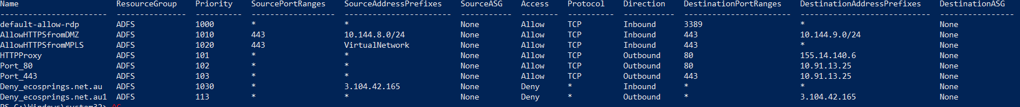

**Step7:** We need to update the same on NSG Tracker.

**Note**: If you received the script disabled error, please follow the mentioned command to fix

Command: **Set-ExecutionPolicy -ExecutionPolicy Unrestricted**